WEEK OF 5/4 | MONDAY | TUESDAY | WEDNESDAY | THURSDAY | FRIDAY
THEME:Plants and Flowers | This is schedule | goes with the 4/5 | year old packets
BOOK | Ten Seeds by Ruth Brown  Growing a Garden by Mari Schuh | The Tiny Seed by Eric Carle | Flower Garden by Eve Bunting  Growing Vegetable Soup by Lois Ehlert | How a Seed Grows by Helene Jordan | Who is in the Garden by Vera Rosenberry
ELA | What a Plant Needs booklet  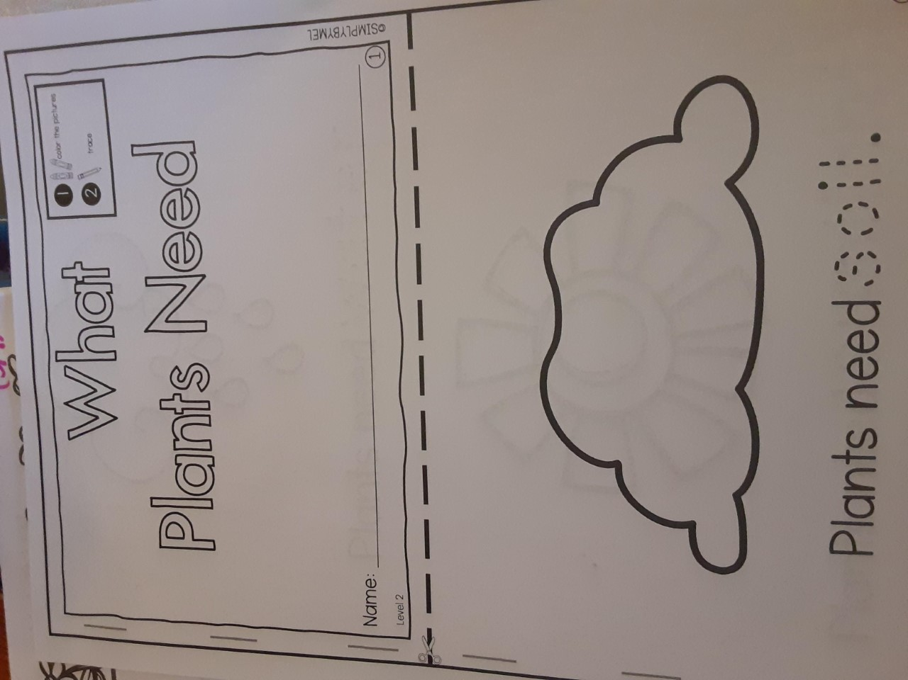  Letter Cards- work on these at your own pace this week!  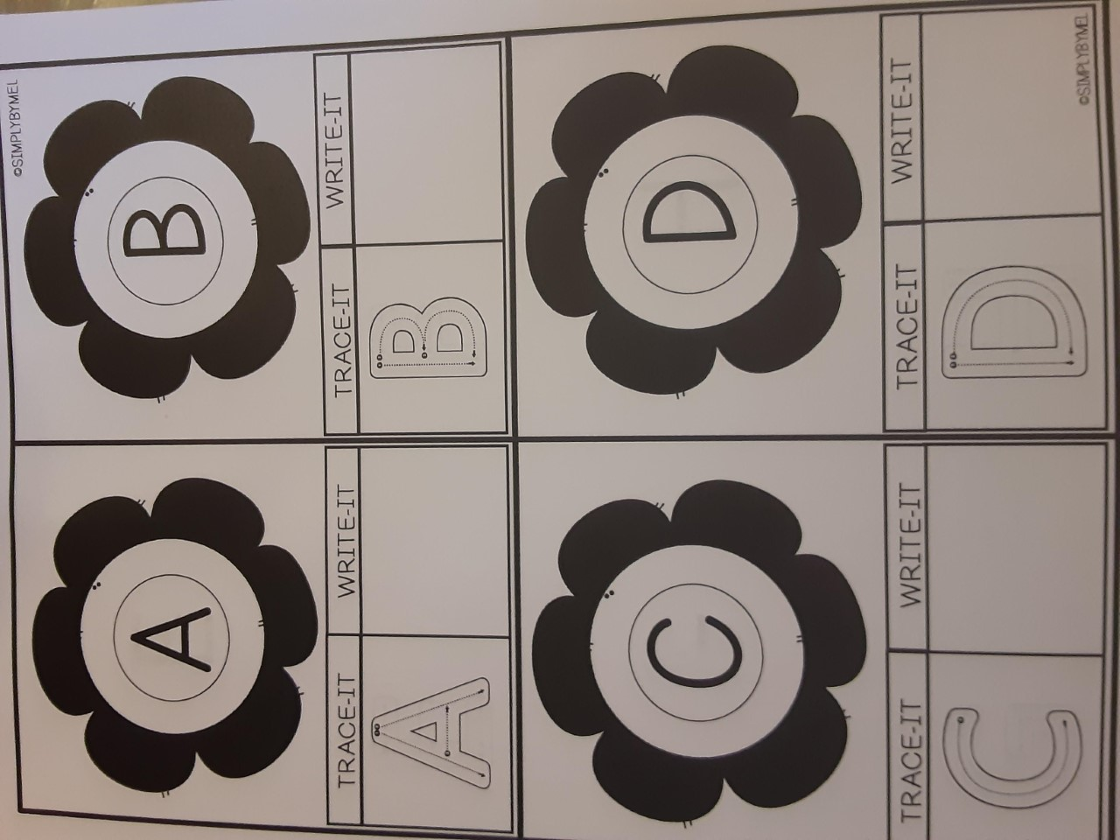 | Complete Day 1 in your Bean Journal –in packets  Tell your grown up the steps you took to make your Bean Sprout House in the baggie. Have them write out what you did, you can add it to you bean sprout journal page for Day 1  Practice reading your What a Plant Needs Book | What does a plant need?  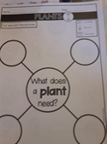  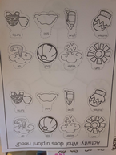 | Plant Parts we Eat- there are a few pages that go with this. Work on these today and Friday.  Do you know the different parts that we eat?  Roots, Stems, Flowers, Seeds, Leaves  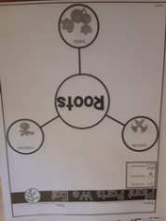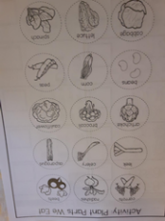 | Finish anything you didn’t get to and practice reading your What a Plant Needs book  Did you finish your letter tracing and letter writing cards?
MATH | There are 2 different Number puzzles that can be cut out. Have your child practice putting the number puzzle bag in order. These can be worked on through out the week. They can color the pictures first and on the one, they can trace the numbers as well.  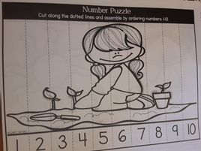 | Plants 1-2-3  Can you write your numbers? Try to write or trace. If not, then use the number page to cut and glue them on.  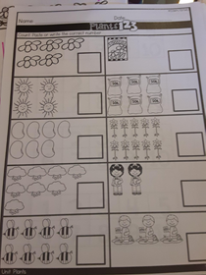 | What Comes Next?  There are 3 of these pages in your packet. These can be worked on through out the week. 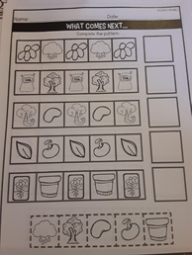 | Work on your patterning- what comes next sheets and play your number game puzzles.  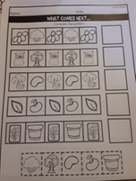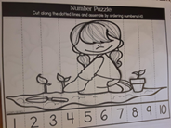 | Work on your patterning- what comes next sheets and play your number game puzzles.
Science | Grow a Bean Sprout Houses- see packets  Did you plant your seeds yet that Mrs. Lewis sent home? If not, be sure to plant them in your little planter. You can get dirt and soil right from your yard. | Parts of a Plant and Plant Life Cylce- both age groups have this in their packets- they might just look a little different  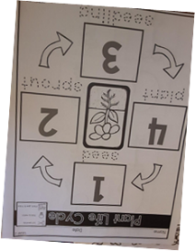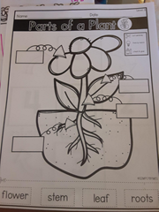 | Check your bean, how is it doing?  Do you see anything yet? Any changes? Make some observations and tell your grown up what you see. | Check your bean, how is it doing? | Check your bean, how is it doing?

My school website will still be updated daily with our stories, art activities and additional activites/videos that can be completed and/or watched.

