WEEK OF 5/4 | MONDAY | TUESDAY | WEDNESDAY | THURSDAY | FRIDAY
THEME:Plants and Flowers | This is schedule | goes with the 3/4 | year old packets
BOOK | Ten Seeds by Ruth Brown  Growing a Garden by Mari Schuh | The Tiny Seed by Eric Carle | Flower Garden by Eve Bunting  Growing Vegetable Soup by Lois Ehlert | How a Seed Grows by Helene Jordan | Who is in the Garden by Vera Rosenberry
ELA | Tracing Lines, Drawing lines to Match pictures-  There are lots of line tracing pages for your child to work on this week. Traching lines helps to form good grip and fine motor skills to be ready for writing lines that form letters and numbers. Work on these papers through out the week- see photos--------- | Complete Day 1 in your Bean Journal –in packets  Line tracing pages  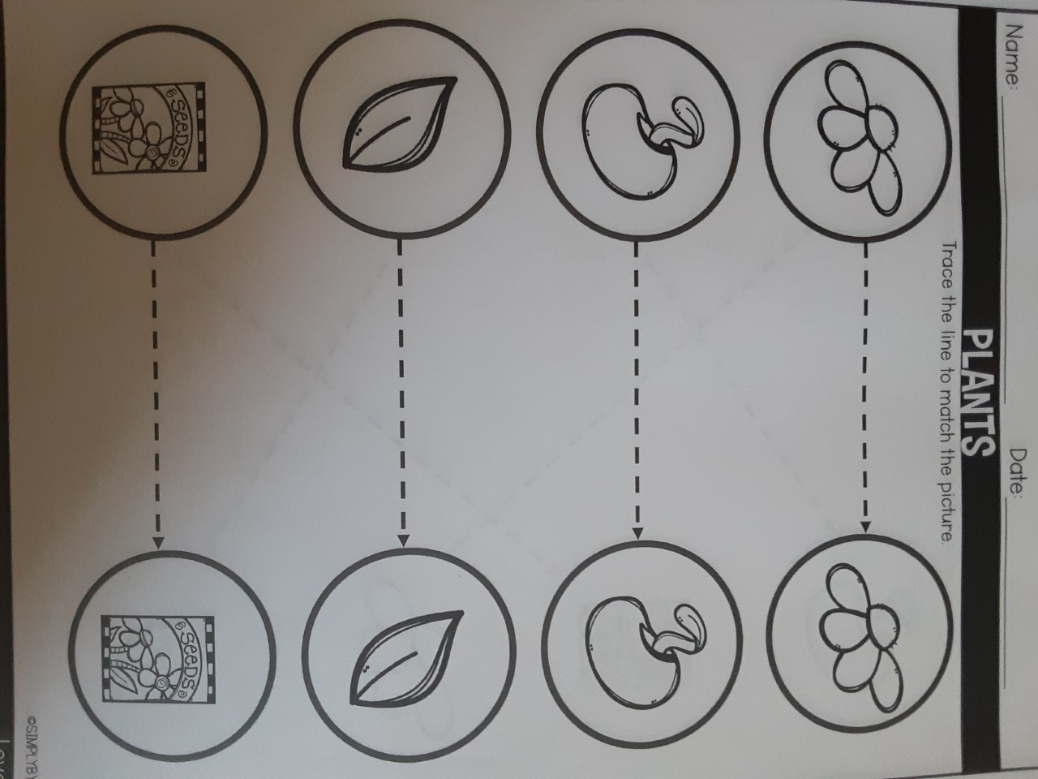 | Journal Page- use any paper-  Do you have a flower garden at home? Draw a picture and tell about it. If not, draw a picture of what you would want your flower garden to look like.  Line tracing pages  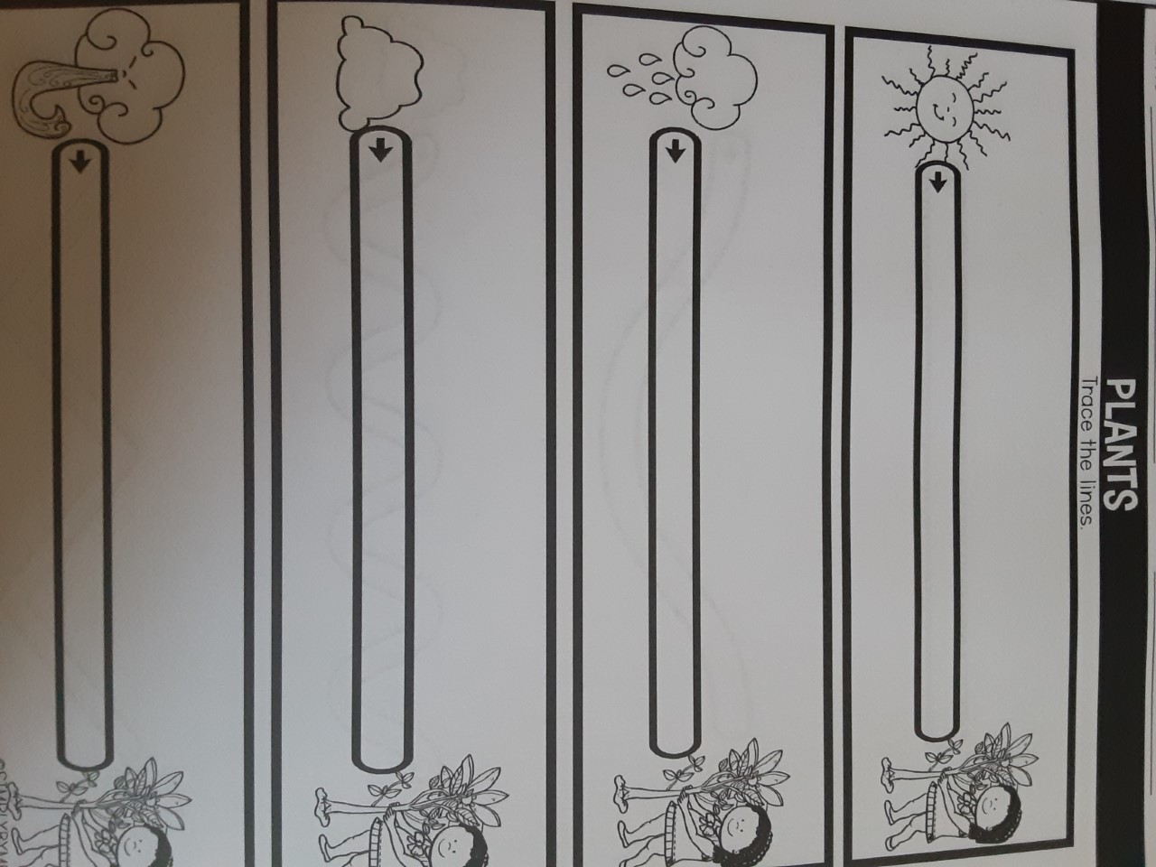 | Journal Page- If you planted your flower seeds that Mrs. Lewis sent home- start a journal and draw pictures of what you are seeing as it grows. Do you see a sprout yet? Any leaves? | Journal page- use your own paper  Pretend you are out playing in a garden. What kinds of creature did you find? Draw a picture and think of a funny name for it!
MATH | There are 2 different Number puzzles that can be cut out. Have your child practice putting the number puzzle bag in order. These can be worked on through out the week. They can color the pictures first and on the one, they can trace the numbers as well. Your child’s go 1-5, this one shows 1-10  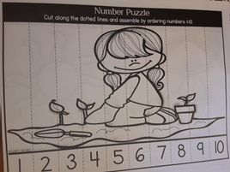 | Plants 1-2-3  Count the plants and plant parts, cut and paste the correct number using the number cards.  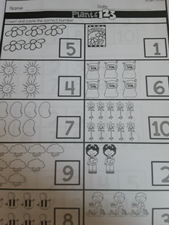 | Plants 1-2-3  Count the plants and plant parts. Trace the numbers!  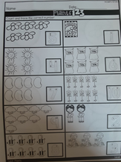 | How Tall are the Plants?  Use any small objects that you have to measure how tall the plants are. Cut the cards out, place objects (beans, pennies, etc) and see how tall each is. For example, 5 pennies tall or 3 beans tall.  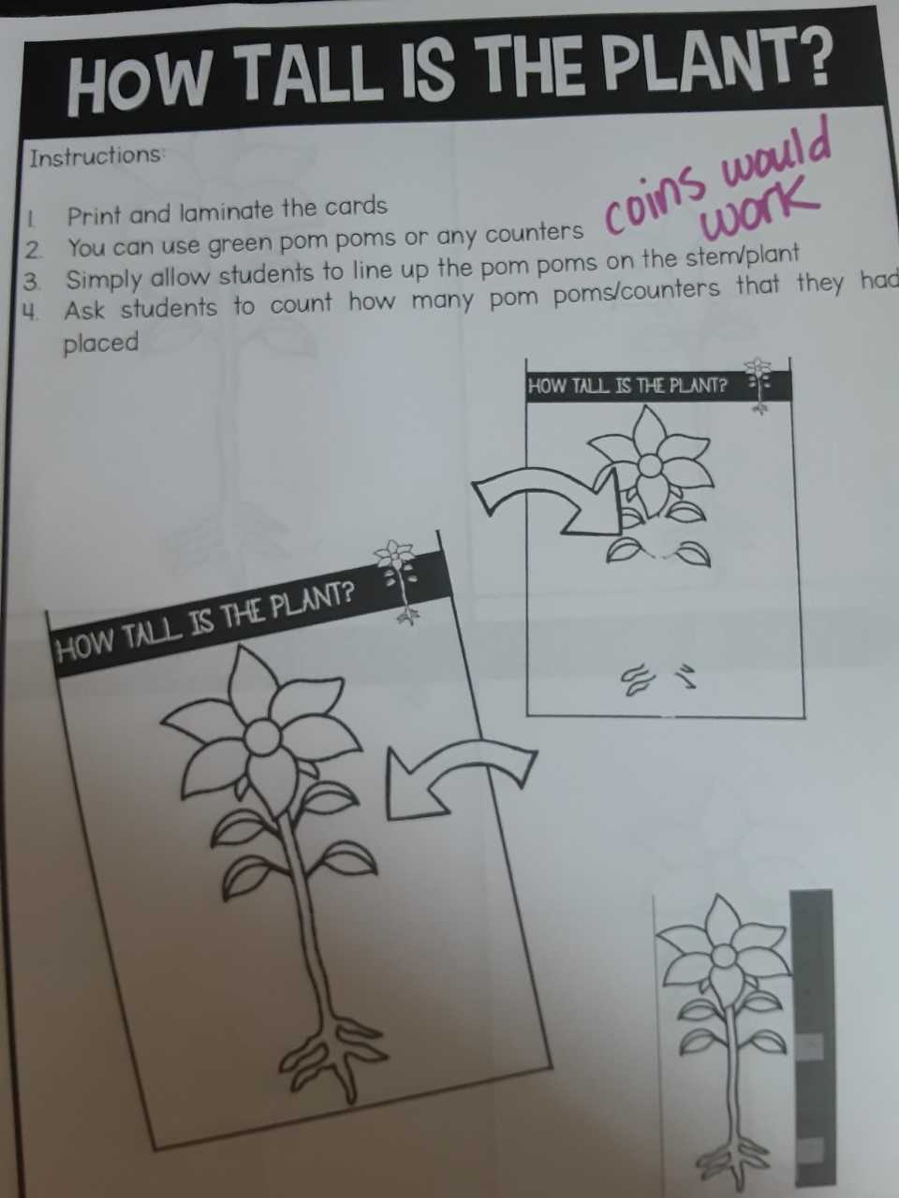 | Strawberry Patch Matching  Cut out the cards and match them to the correct pictures.  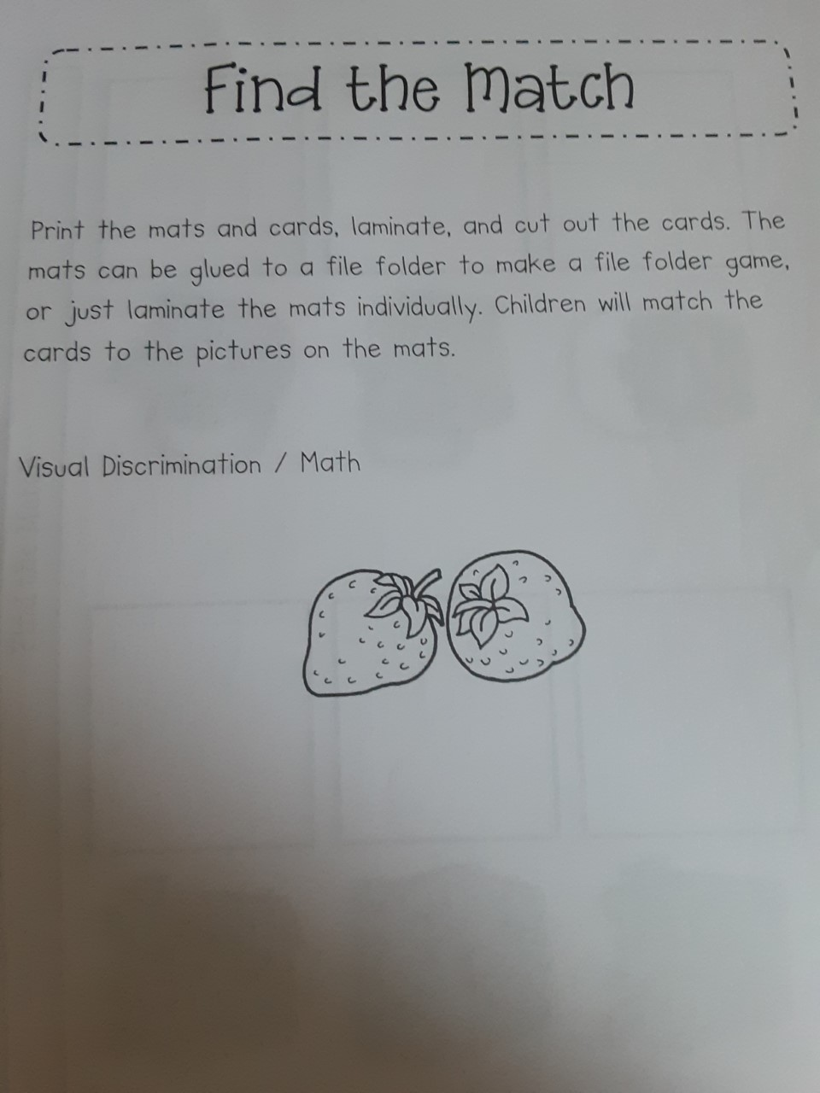
Science | Grow a Bean Sprout Houses- see packets  Did you plant your seeds yet that Mrs. Lewis sent home? If not, be sure to plant them in your little planter. You can get dirt and soil right from your yard. | Parts of a Plant and Plant Life Cylce- both age groups have this in their packets- they might just look a little different  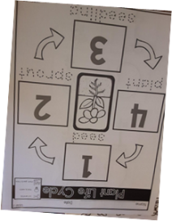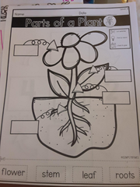 | Check your bean, how is it doing?  Do you see anything yet? Any changes? Make some observations and tell your grown up what you see. | Check your bean, how is it doing? | Check your bean, how is it doing?

My school website will still be updated daily with our stories, art activities and additional activites/videos that can be completed and/or watched.

